

Operation Red Kite
CLASSIFIED LVL1
Operation “Red Kite” is an expansion plan to conquer a large part of land North-West of Axia.
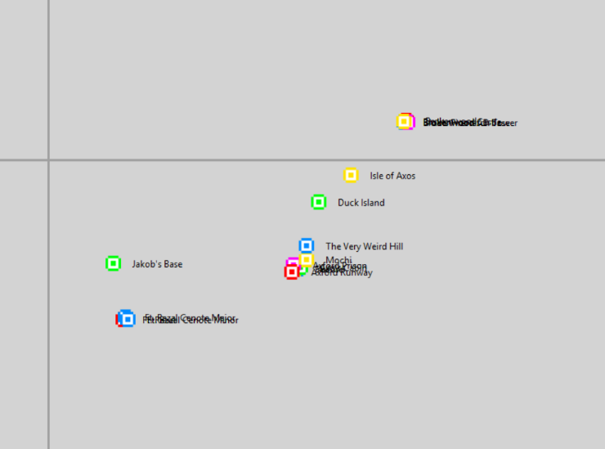
The image adjacent to this text is a map of the current territories, Operation Red Kite will work through the use of several control bands stretching to the current band to Ft. Razal where they will all converge. To summarize:
- A group of military personnel will meet at Brokenwood. All with enough fuel to make the journey


- The personnel will be positioned along the Axia-Brokenwood control band, all of which will have a compass pointing to Ft. Razal.


- Once receiving a command from the Lord, the personnel will fly to Ft. Razal from their positions on the existing Axia-Brokenwood band.
- Once the personnel reach Ft. Razal, they will go back to Axford and discuss colonization exactly North-West of Axford to reinforce the “Control Net”.
- The colonization will take effect in the following days.

